How to access the US National Archives and Records Administration (NARA)
WWII aerial imagery flightpath overlay graphics for 1 deg by 1 deg cells:

By Matt Poole, genius (and generally a nice guy…), current to 5 April 2022

The aerial imagery flightpath indexes are broken down into 1 x 1 deg cells, IDENTIFIED BY THE LAT/LONG OF THE LOWER LEFT CORNER.

FIGURING OUT AIR PHOTO COVERAGE:

THE FLIGHTPATH OVERLAYS ARE ON NARA’S WEBSITE, so I, and you, can do searches at home. However, sometimes there is not a reference map…and it’s hard to figure out precisely if a flight line covers your area of interest.

Here’s how you view any overlays in a 1x1 cell of interest:

Take 24N, 93E as an example.

Go to the website:

www.archives.gov/research/catalog

You will get a form. Here’s a crop of the top of it:



In the “Search the National Archives Catalog” box – NOT IN THE SEARCH BOX AT TOP RIGHT!! – type in the following: 24N093E . The latitude is two digits and a letter, but the longitude is always three digits and a letter. No spaces.

Hit Search. You will get this (cropped version):

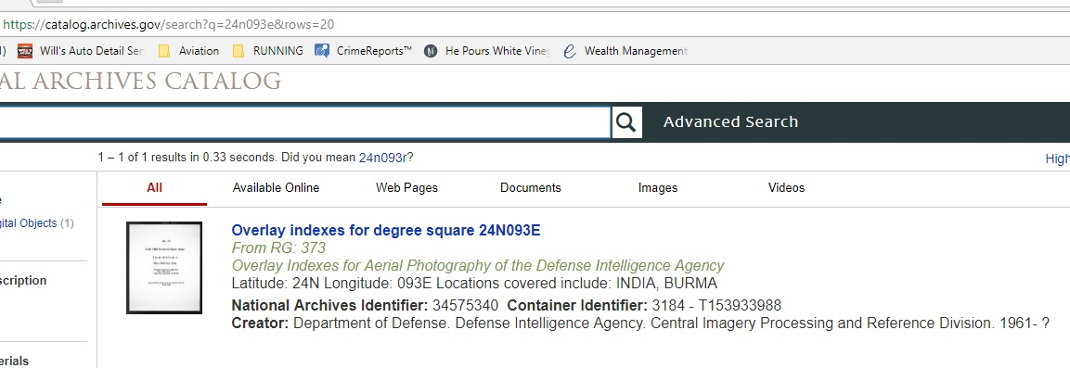

On your monitor, position your cursor on the LOWER RIGHT corner of the black rectangle shown above, and double-click. This is the easiest way to get to the beginning of the index overlays for degree square 24 degrees North, 093 degrees East.

Now, you can just move your cursor to the right of the resulting first image, and a right-facing arrow will appear to advance to the next image. Click on it to display the next image. And so forth. Each individual flightpath overlay will display, one at a time.

Note that EACH OVERLAY DISPLAYS AT THE EXACT SAME SCALE AND POSITION ON YOUR MONITOR. In other words, each overlay, as it first appears, is registered to the same spot on your monitor. So if there is a reference map, as there is for the 24N093E degree square, and if it is clear enough to you, you can estimate your lat/long location for any point you need to reference. Add a piece of tape to your monitor pointing to the spot. Then, when you click on the arrow to bring up the first overlay, and the next, etc, you can gauge whether or not the flightpath on any one overlay hits your area.

It is not user friendly, and it is not exact, but it’s pretty good.

You can zoom in to any displayed overlay, as well, but this will un-register the image to the perfect display positioning in reference to any other overlay and the base map. No problem. Just go back to the previous overlay, and then go forward again, and the overlay you had enlarged will now be back in it’s perfect position relative to the other overlays.

Note, also, that when you zoom in, the resolution is still good.

Lower resolution copy:

You can save any one overlay individually by hitting the right mouse button and clicking on “Save image as”. Then name the download accordingly and save it to a desired hard drive directory. YOU WILL BE SAVING WHATEVER DISPLAYS ON YOUR MONITOR. If you had zoomed in on something, and you go to save the image, you will ONLY save what you are looking at – NOT the entire 1x1 area of that overlay. If you want to save the entire overlay, make sure you first display the entire overlay.

And this is important: if you don’t save a zoomed-in view of the legend or a zoomed-in view of frames covering your area of interest, enlarging the saved overall 1x1 area will not be ideal resolution for reading the inked text, IF YOU ONLY SAVE WITH THE RIGHT-CLICK-AND-SAVE METHOD. Don’t assume that the resolution of the text will be good enough if you had saved just the entire image. Instead, zoom in upon anything you need a close-up of, then hit the right mouse button and choose “Save image as” to give you improved resolution. It still may not be great, because some of the overlay info is hard to read.

A BETTER SAVE ALTERNATIVE, at a much higher resolution:

With any full 1 x 1” overlay displaying on the monitor, you MUST click on the icon circled in red:

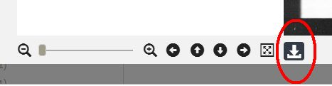

After you click on the icon, and the image repaints, THEN right-click and choose the save image as an option. And so on. This saves it as a jpeg, at a good resolution. Vastly superior to the copy (which isn’t a jpeg) you get when you don’t use the icon!

+++++++++++++++++++++++++++++++++++++++++++++++++++++++++++++++++++++++++++++++
If there is no base map, you might have to go to the University of Texas map library’s 1:250,000 US Army Map Service map covering your area and figure out the lat/long. (Ask me for help in finding the website and the location of the 1:250,000 maps – some seem to be difficult to find.) Or, just by using a divider or a scale and simple math, you use the corner ticks/30 minute center longitude line and measure the distance to your precise lat/long spot. THEN add a piece of tape to your monitor and continue seeing if there are any other overlays covering your area of interest.

Here's one of the overlays for 24N093E – the one containing the best imagery for the Hurribomber bridge site [EXPLANATION: This was a past project I worked on.], which was in film can F10330. I have cropped it slightly, but it shows the full size of the original acetate overlay:

(SEE NEXT PAGE)
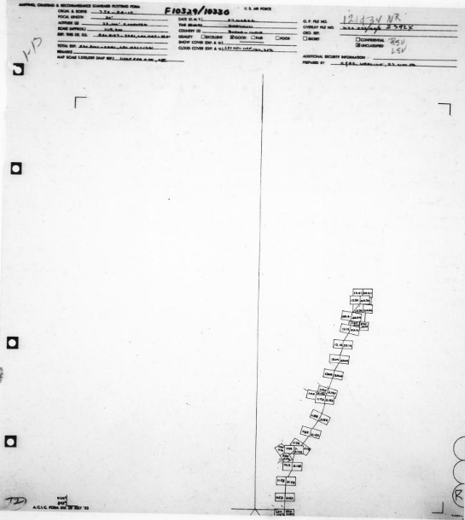

Note how small the image coverage rectangles are. This is because this mission shot imagery at a “SCALE (APPROX.)” of about 1:13,200 – or so it looks on the blowup of the legend:

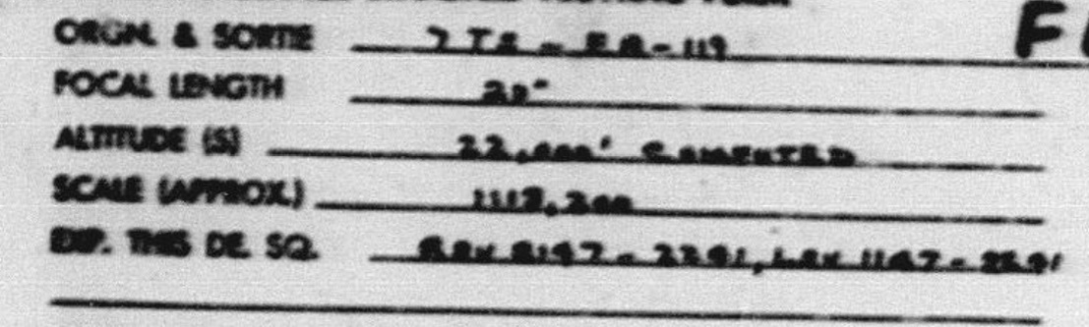
At the top, pay attention to the rating: Excellent, Good, Fair, Poor. Good is often not so good. And clouds can interfere with detail greatly, too.

The best imagery is under 1:20,000, if there isn’t bad cloud interference or if the quality of the film is deemed OK. Then the detail gets worse as the scale changes, and many flightpaths were for general recon imagery flights covering wide expanses of area. They are NOT good for fine detail. We lucked out with the Hurribomber bridge site!

Anyway, you will have a field day checking out your areas of interest now. THIS DOES NOT MEAN THE FILM EXISTS AT THE ARCHIVES. Some of the film is mysteriously gone!

Right! I hope you get something out of this.

Cheers from Matt (genius and generally a nice guy…but I already said this at the start).

